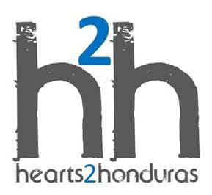
Registration/Medical Information Form: Honduras Trip Date ____________________

__________________________ ______________ _____ ________________
Name as on Passport : Last First Middle Name called

___________________________ __________________ _______ ____________
Address: Street City State Zip

_____________ ______ ___________ ___________ ____________________
Your Phone # Sex (M/F) Birthdate Passport # E-Mail

________________________________________________ ______________ Occupation Traveler’s T Shirt Size

___________________ _____________________________________
Talent to share Beneficiary name for our short term missions insurance

Are you interested in sponsoring a child’s education? Yes or No Male or Female?

CANCELLATION POLICY:
The nonrefundable deposit is NEVER refunded. If cancellation is 90 days or more before the trip 75% of
total trip can be refunded....89-61 days before the trip, 50% of total trip can be refunded....
60-31 days before the trip, 25% of total trip can be refunded...30-0 days before the trip, no refund.

I am allergic to: Foods: ___________________________________

I am allergic to: Medicines: ________________________________

***PLEASE FILL OUT ALL LINES AND ATTACH A COLOR COPY OF YOUR PASSPORT AND ALTERNATE ID ON ONE PIECE OF PAPER***

